**Creating a Windows Virtual Machine in Microsoft Azure SOP**

**select Virtual machines**

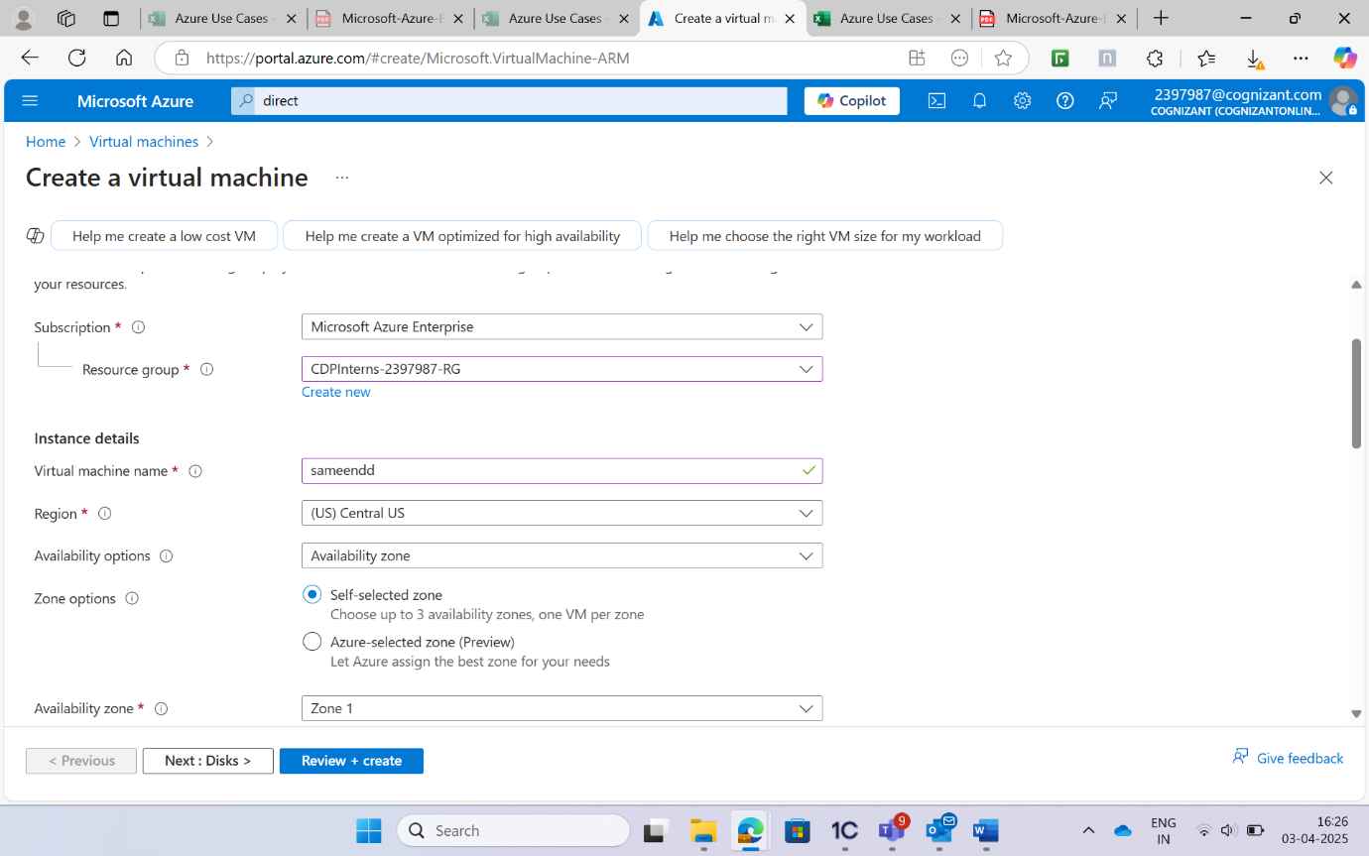

**In disks make sure that the Use managed disks is set to yes.Leave networking, management, Advanced and Tags to their default values and click on the Review + create button at the bottom of the screen.Once you get a Validation Passed message, click Create at the bottom.Click on the virtual machine name to go to it.**

